**How to create your own virtual machine in azure**

Considering that you guys know the basics of cloud computing and azure I would start with creation of virtual machine.

Step 1: Login to your Microsoft azure account.

<https://portal.azure.com/#home>

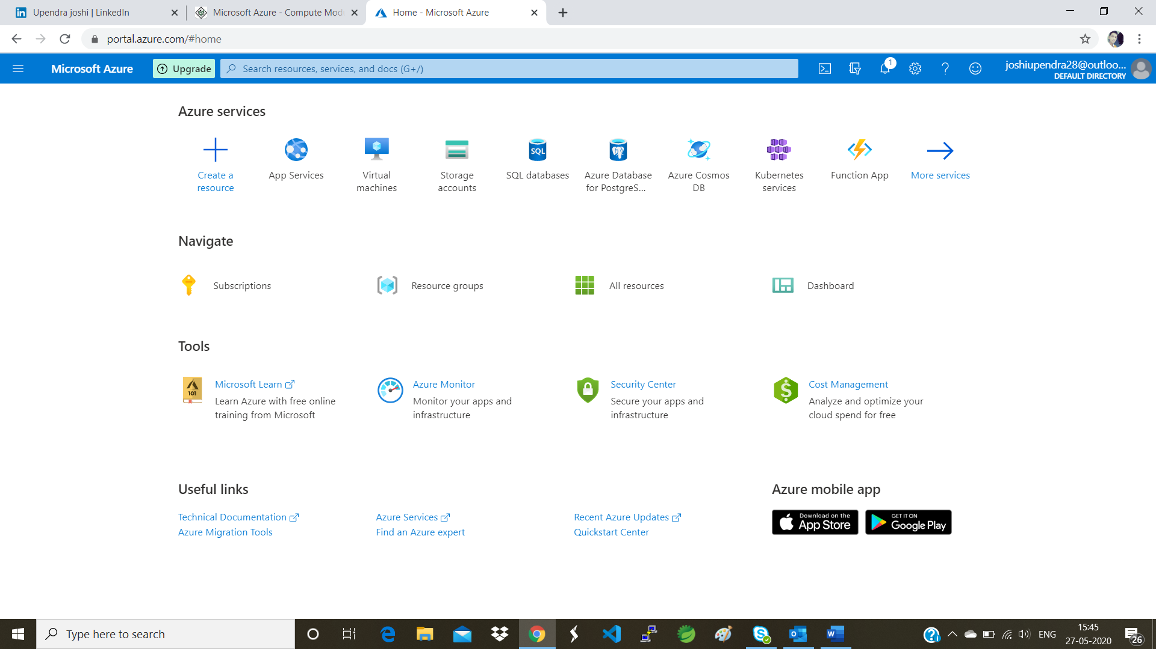

Step 2 : Click on create a resource you will see below screen.

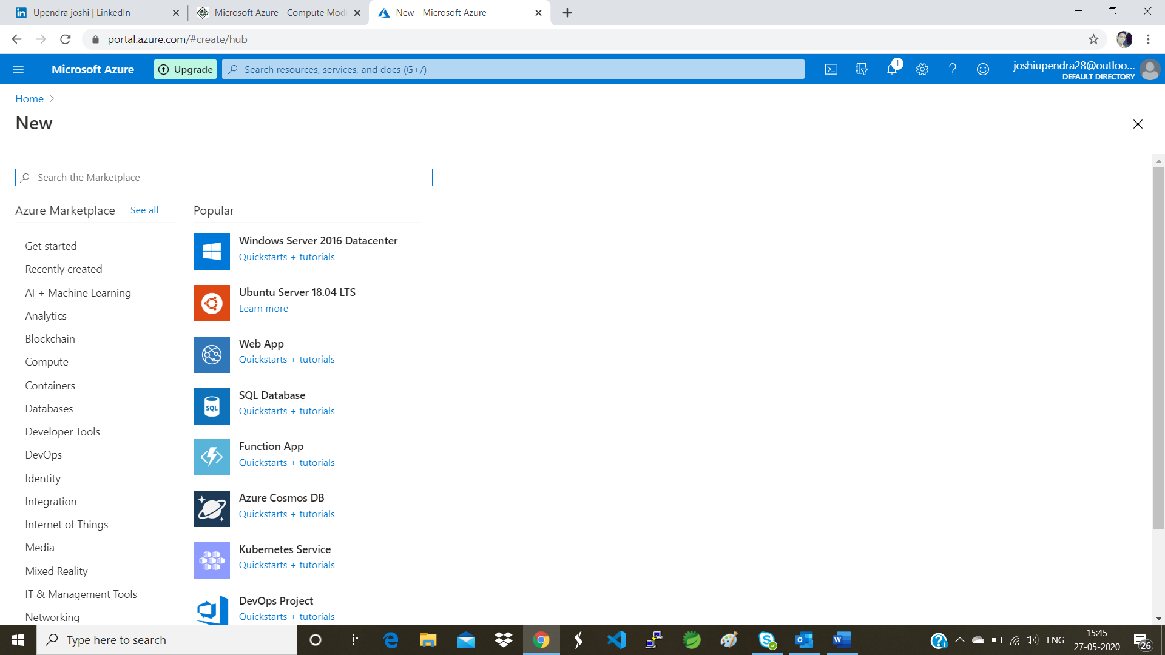

Step 3: On the left side screen you will see compute option click on compute option.

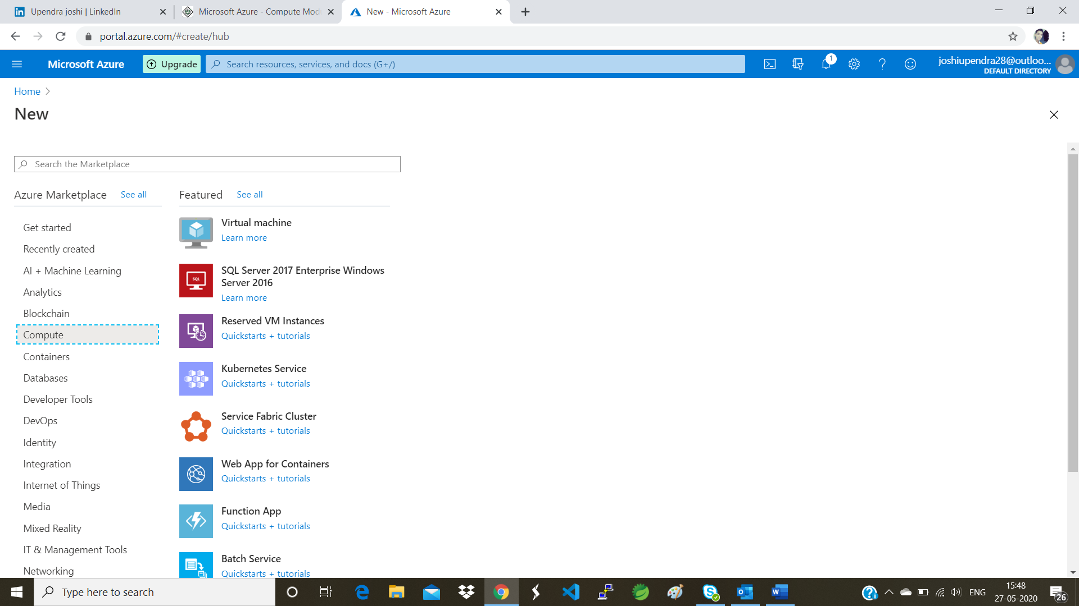

Step 4 : You will find virtual machine option at the top click on that.

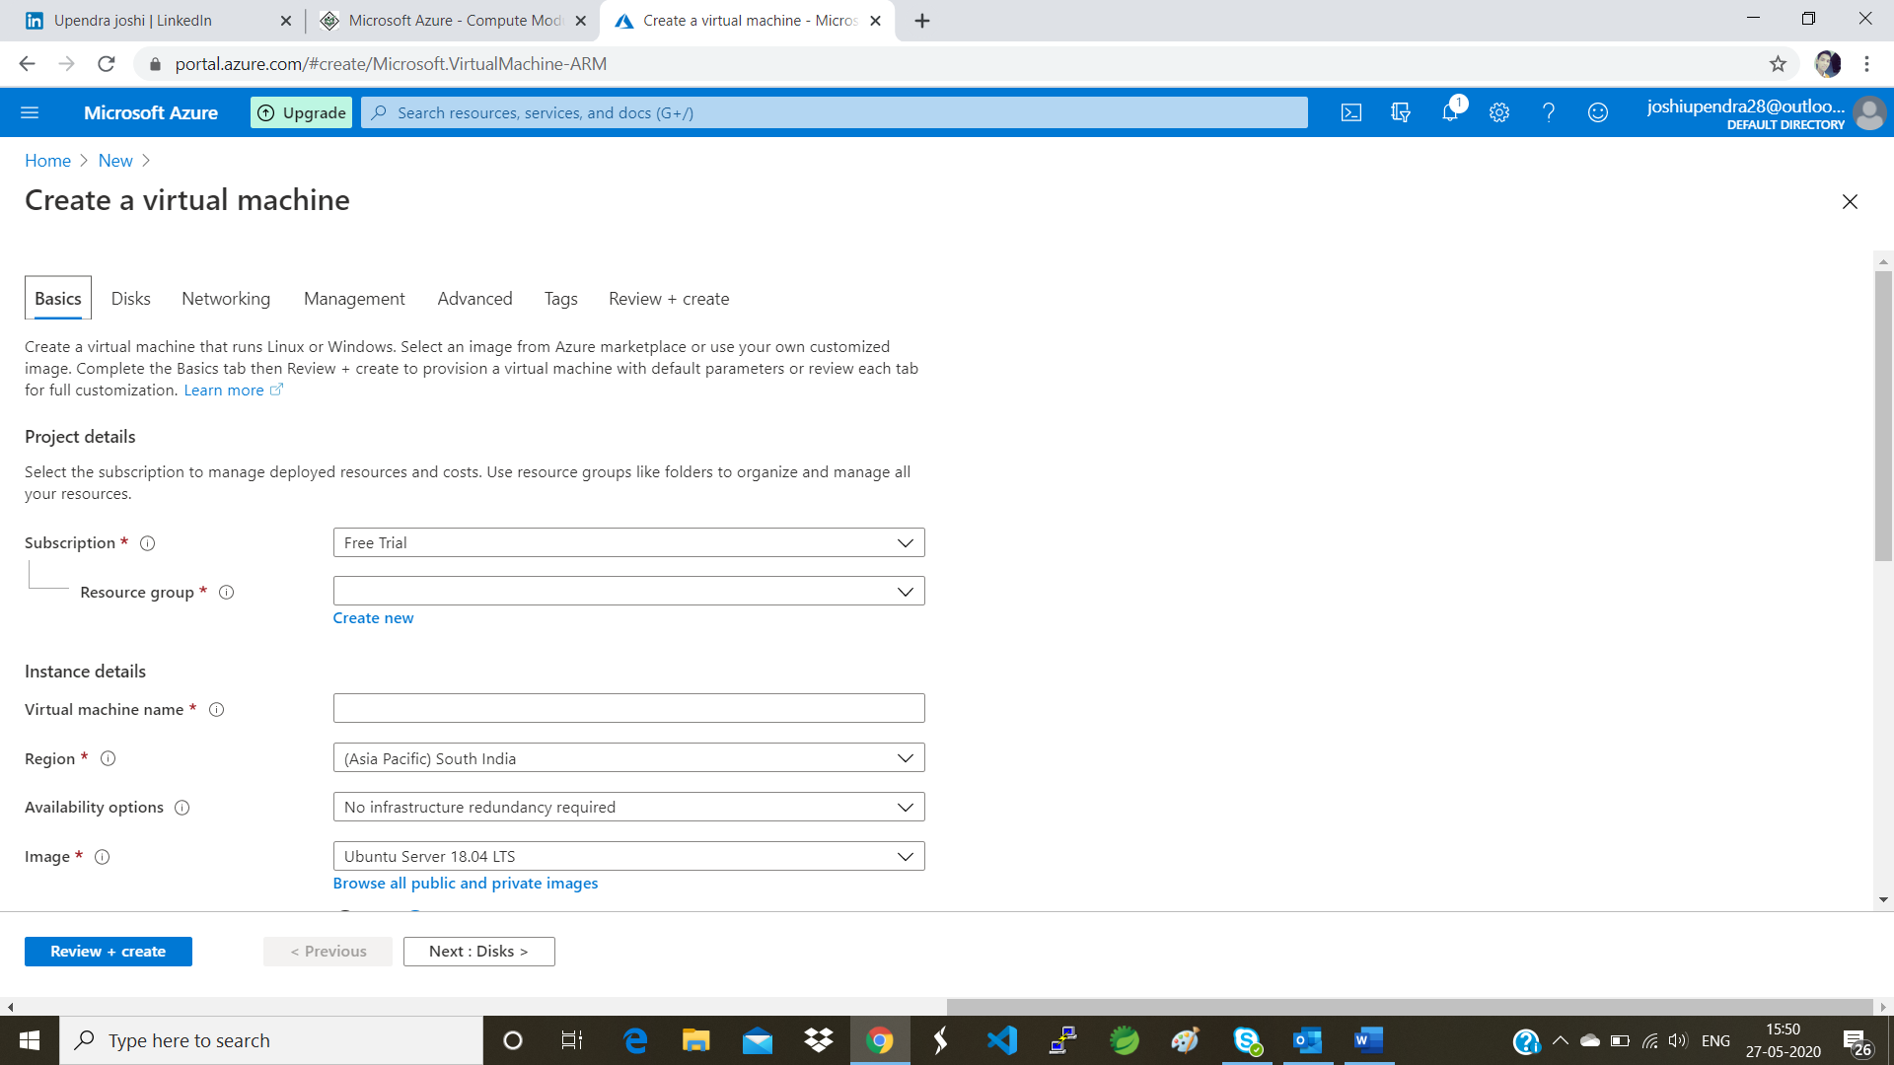

Step 5 : Fill in below details in subscription keep it as free trial only if you are doing it for study purpose.

In resource group you can either select the existing resource but if you doing it for the first time I would suggest create a new one and select it.

Give a proper name to your virtual machine I would give it as windows server since I would be adding windows OS to this vm.

Select a proper region from where this vmware would be accessible I would select EAST US.

The reason being when you check out for other regions you would probably not get the memory slots. Better go with available once if you are just doing it for learning purpose.

Availability options keep it as it is.

Image would select windows 10 pro you can select any of linux distro or windows distro.

Azure spot instance keep it no.

Size as I mentioned above the regions you select you will get the slots as per that you can rearrange the size if you feel the cost is going higher from the free credits you are holding I would go for 2 cpus each for 8gb.

Enter your username password as per the criteria.

Now for inbound ports selection I would suggest you go for http and https as we would accept the request coming from above http and https protocols only.

For already having windows licence select no.

Now click on review and create

Review your configuration once more before finally creating.

Now click on create.

It will take around 5-10 minutes.

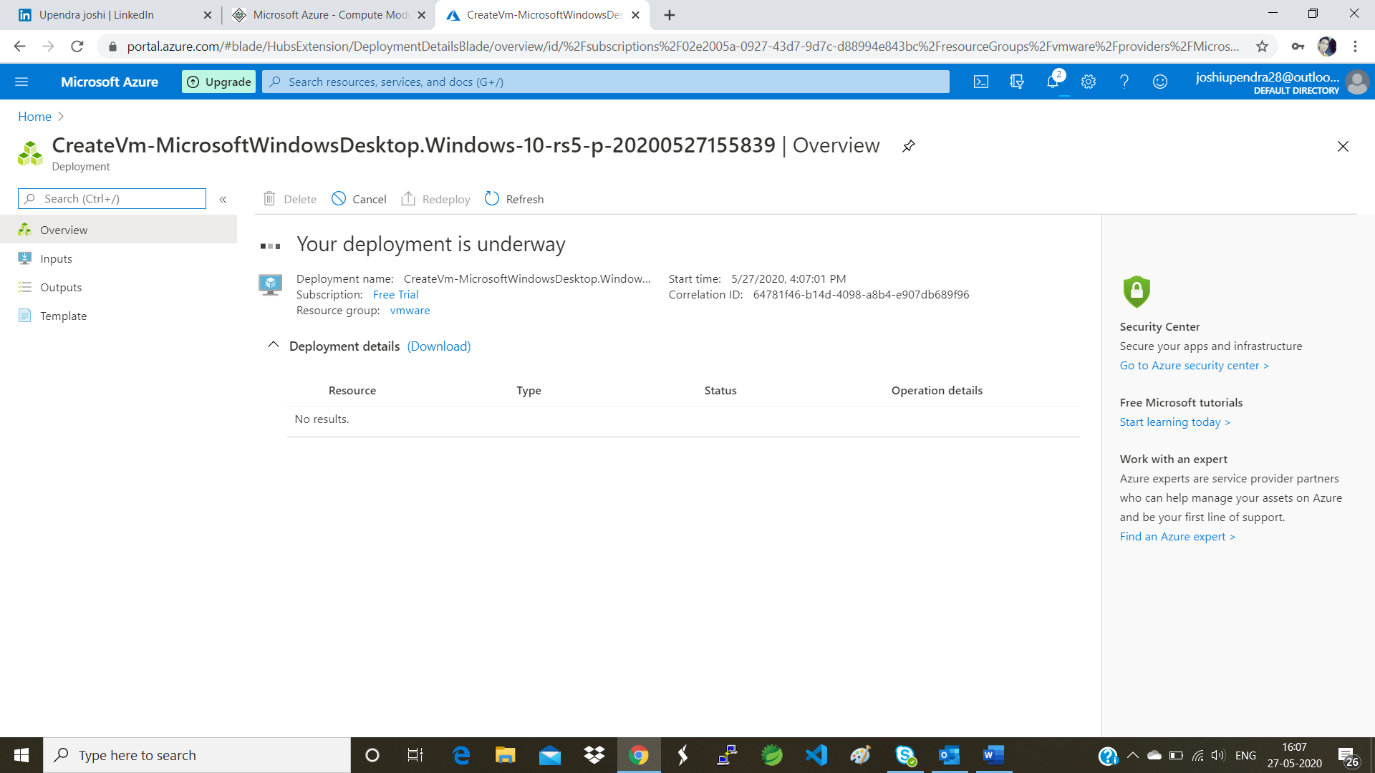

Step 6 : Now that you have completed with the deployment of your vm it would look something like this.

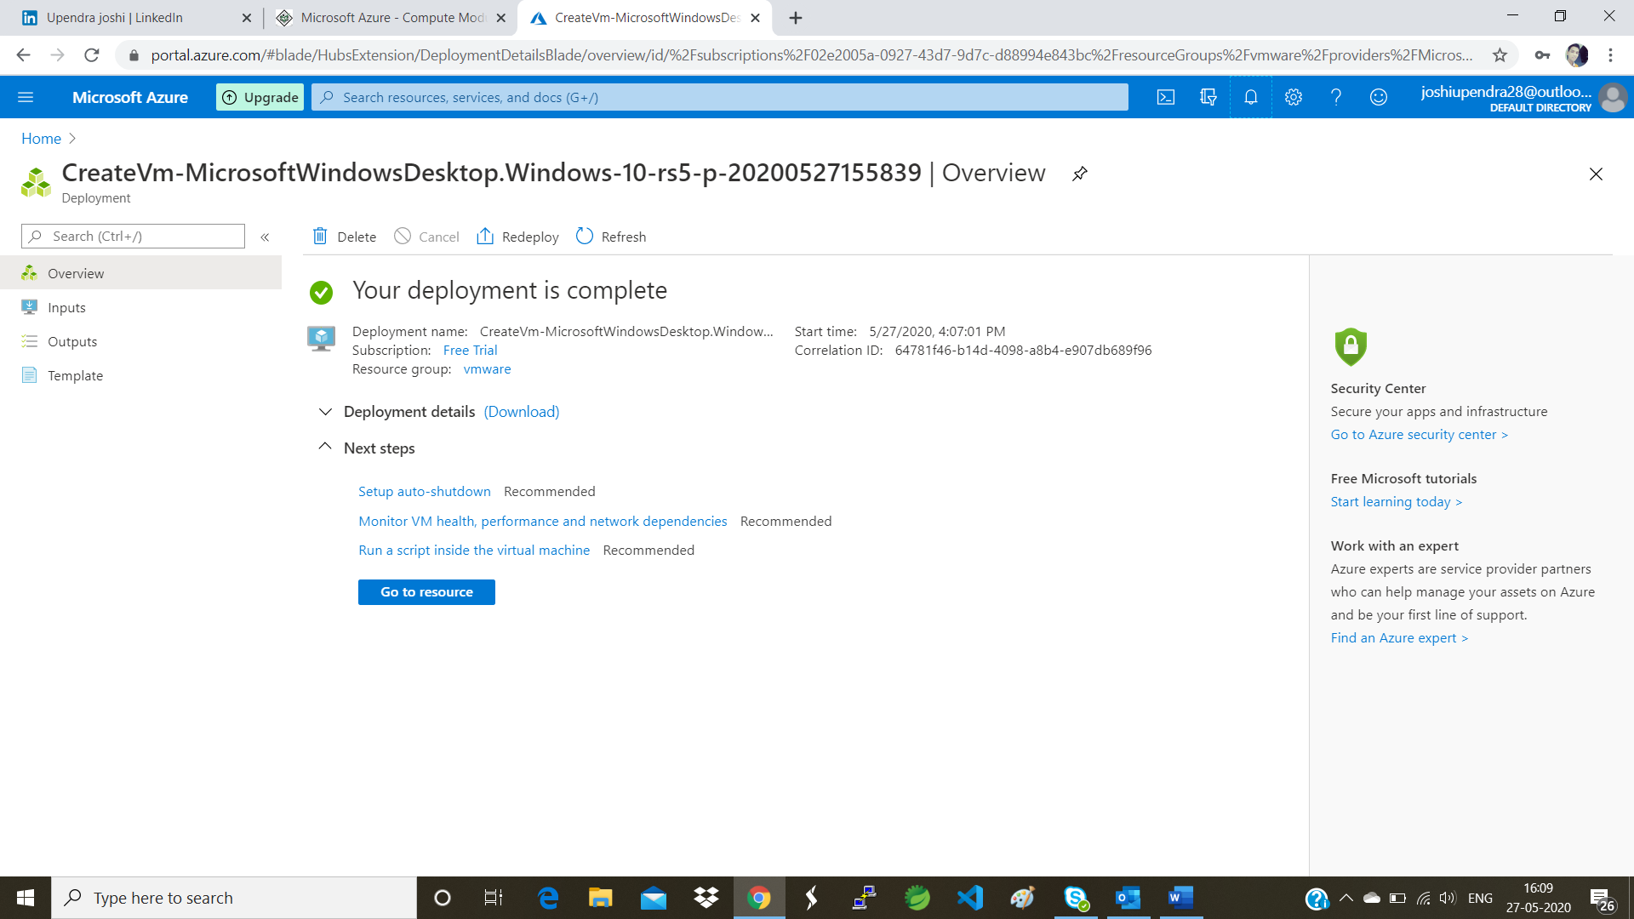

Step 7 : Click on go to resource.

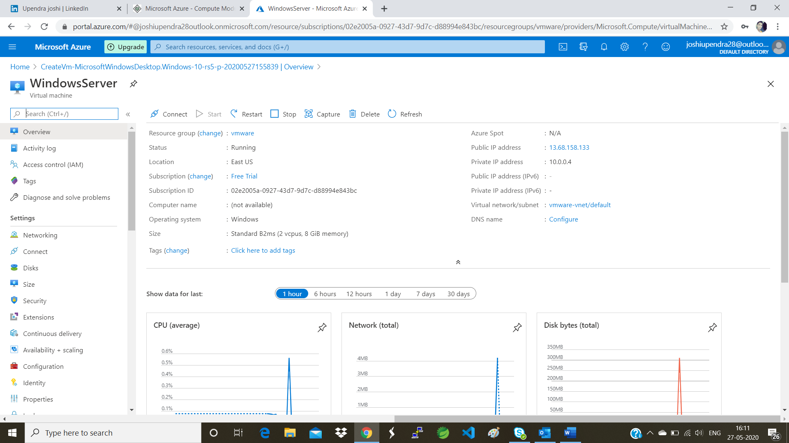

Step 8: Now to access this vm machine you need to click on connect option in the left menu.

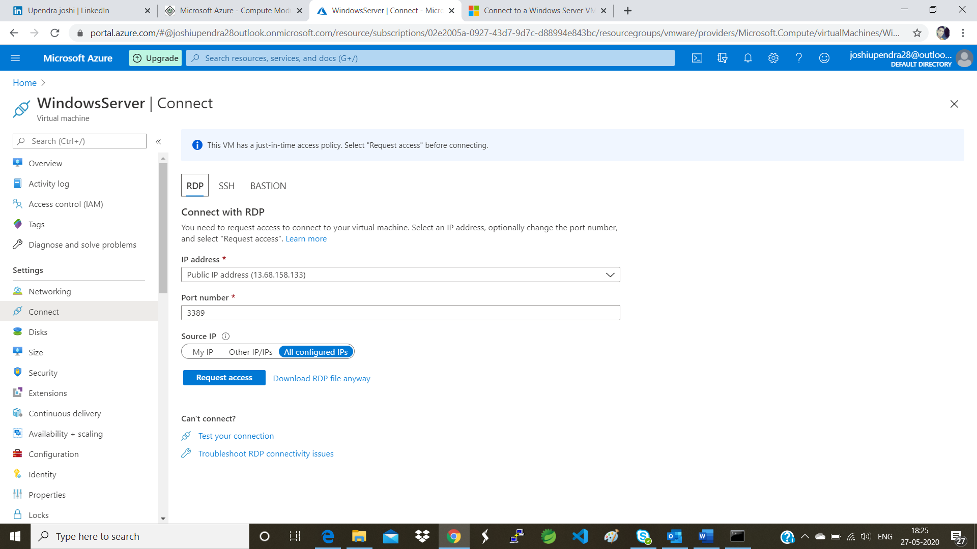

9 . Now before proceeding to Download RDP(remote desktop) verify whether just is time access policy on the top verified if not please do it. Next get your system ip using cmd command ipconfig.

And clicking on the other ip option paste your system ip there and click on Request Access.

And finally Download the RDP.

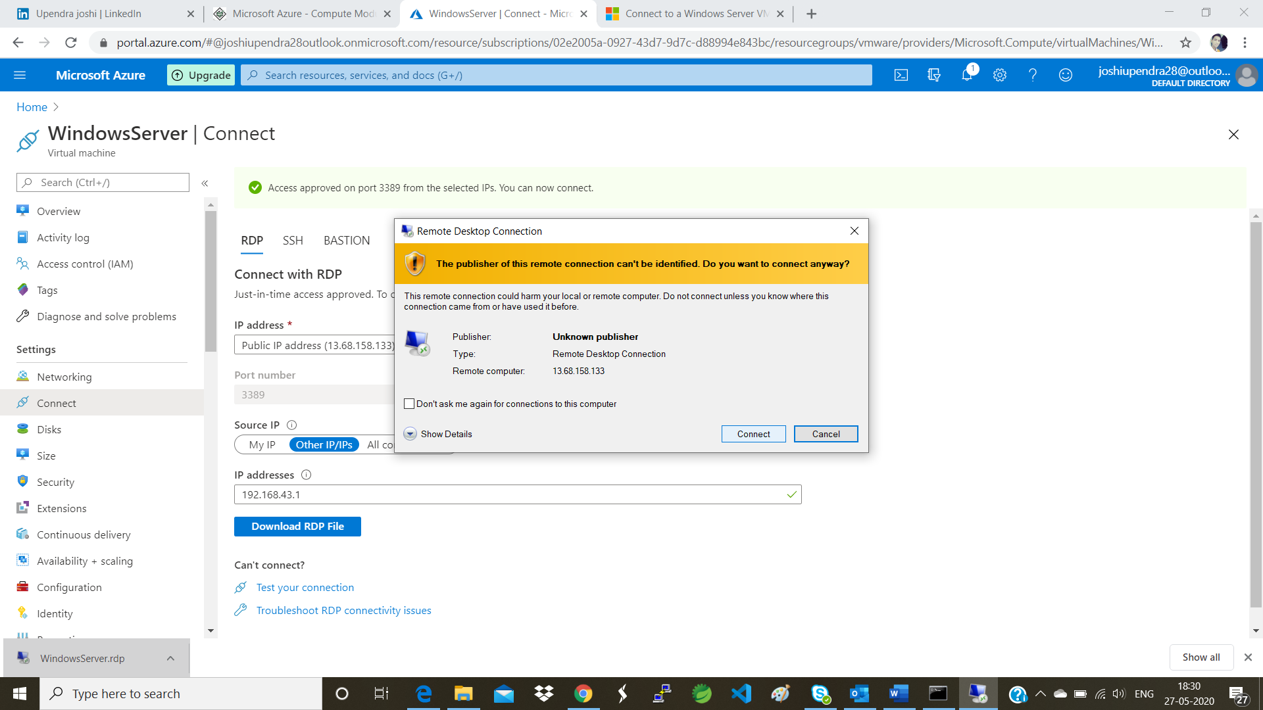

10. Finally you will need to enter your credentials and then press yes that’s it enjoy your first windows OS on your VM.

